Evaluation for prototypes

Overview
In the first two iterations, we used heuristic evaluation and field study and respectively for each prototype.

The reason for heuristic evaluation in the first iteration was that by referencing Nielsen's 10 usability heuristics, we could quickly figure out our problem in the early process and there was no need to recruit volunteers.

We chose field study in the second iteration with the method of questionnaire. Since the second prototype had already basically achieved the required functions, it was easy for us to find some volunteers and design the field study and collect feedback data.

Contents of Each Evaluation

2.1 Heuristic Evaluation
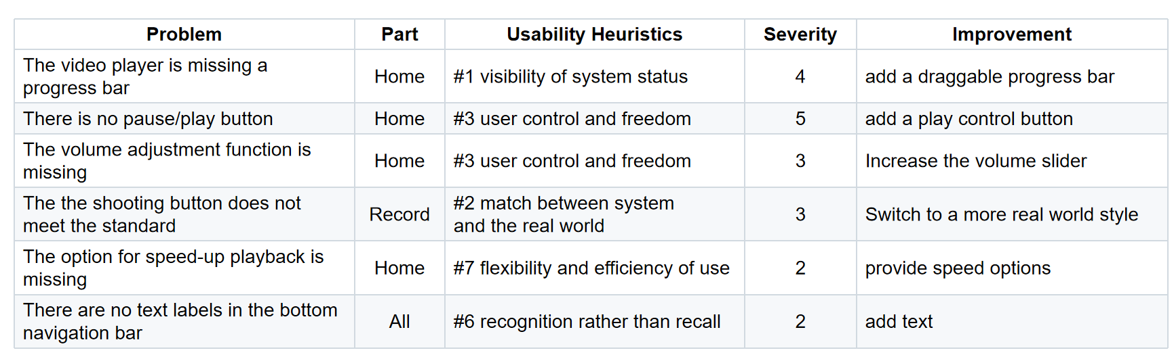
By applying Nielsen's 10 usability heuristics to the first prototype, we got the evaluation chart as follows:
Figure1 Chart Result of Heuristic Evaluation

We discovered that the video player functions are seriously incomplete, lacking basic playback control functions like pause, progress bar, speed and volume. This was related to our misunderstanding of the product. It was initially designed as a simple auto-play mode, but after evaluation, it was realized that complete playback control functions must be provided.

In the next iteration, we planned to redesign the video player by adding reasonable playing functions, optimizing the design of the record page and adding navigation text details.

2.2 Field Study
We recruited 10 volunteers to experience our second prototype and design a questionnaire to collect feedback data. The questionnaire link is https://docs.google.com/forms/d/e/1FAIpQLScJFAorGGpJOkA3LQVgozylU0zbBCK3RWCMOwB3MCJkiO2i2g/viewform?usp=dialog
The questionnaire is an online link with page like this:
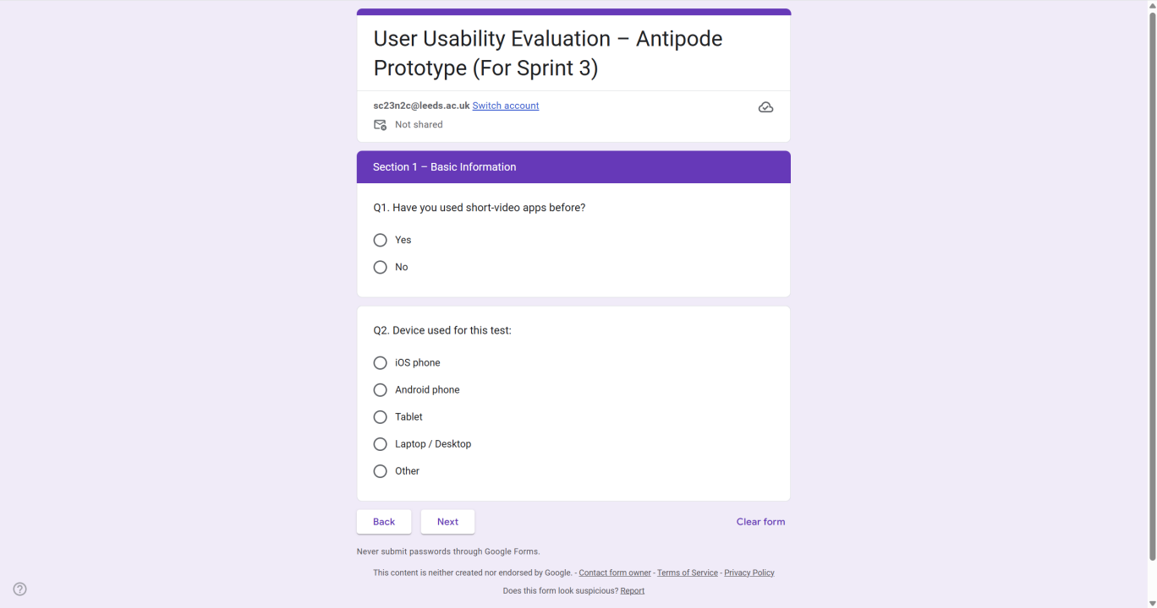
Figure2 Online Page of Questionnaire

The collected data shows that most participants have relevant experience of using short
video apps on mobile devices.

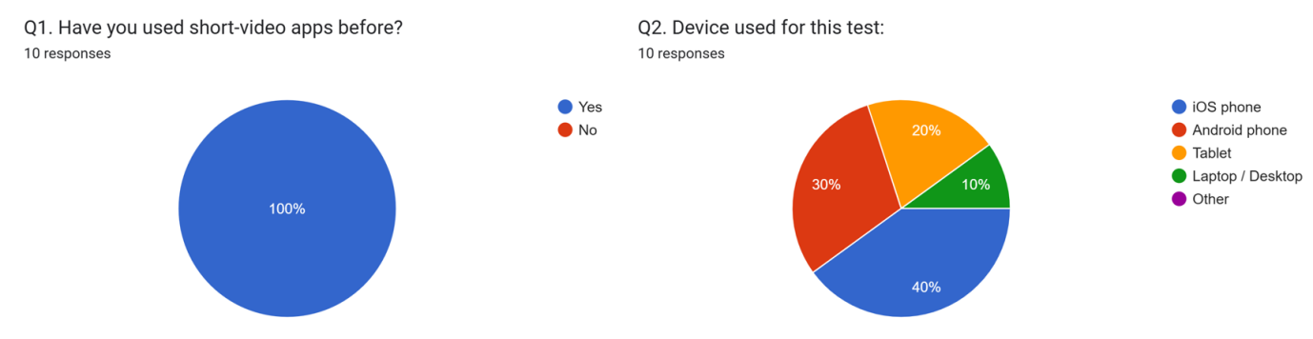

Figure3 Participants Information

The ratings of different functions are as follows:
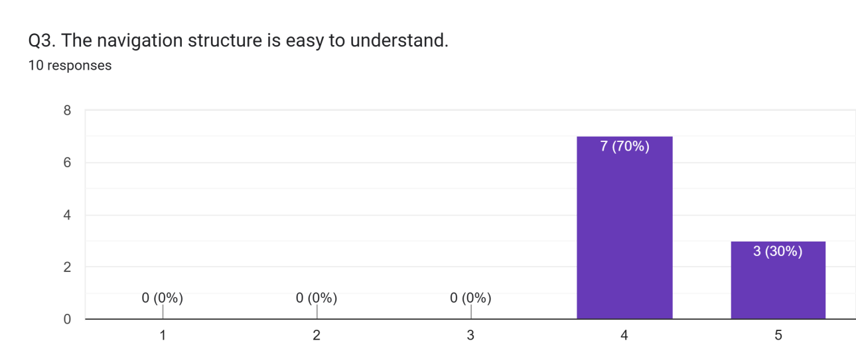

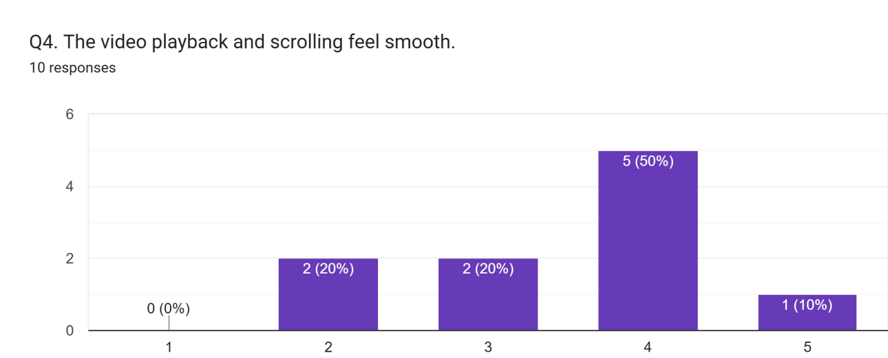

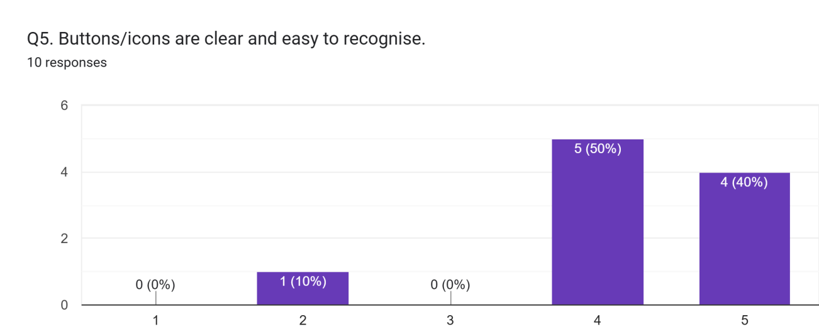
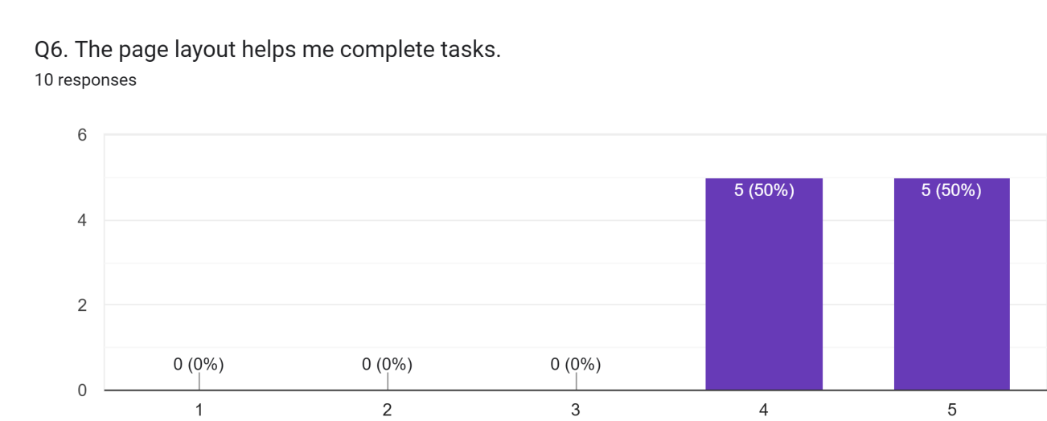

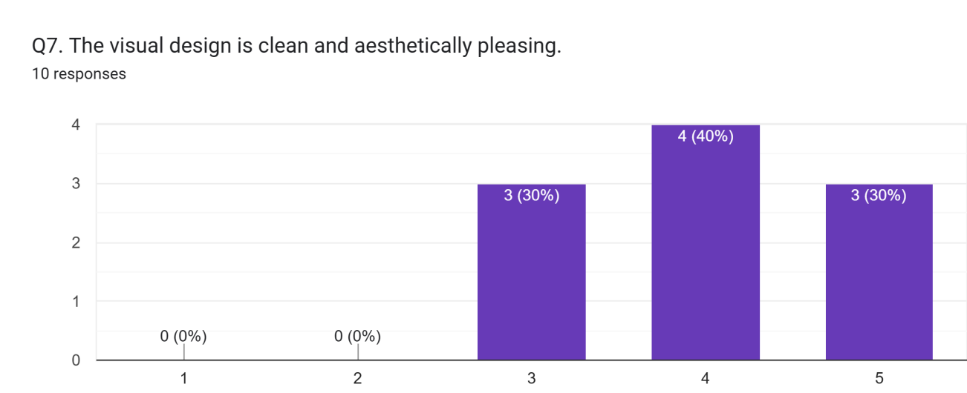
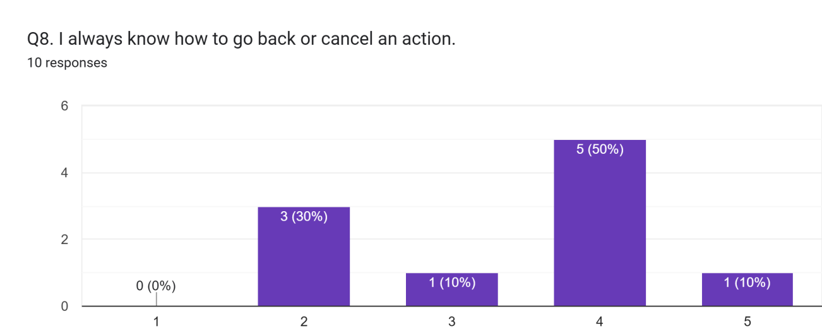
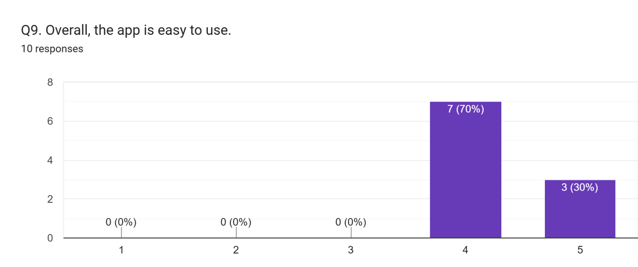
Figure4 Ratings of Functions

According to the ratings, it is clear that volunteers were satisfied with the navigation structure, buttons and icons, page layout, visual design, but dissatisfied with the video playback and scrolling as well as back or cancel action.

The questionnaire also collected participants’ opinions on our prototype, the collected opinions are as follows:
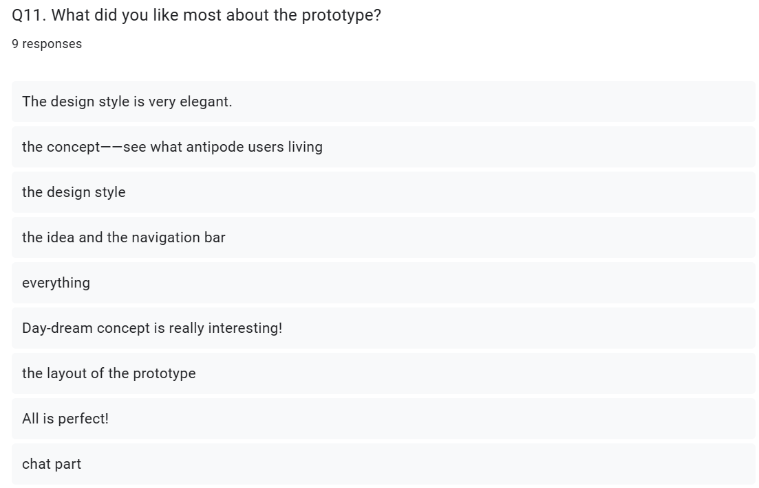

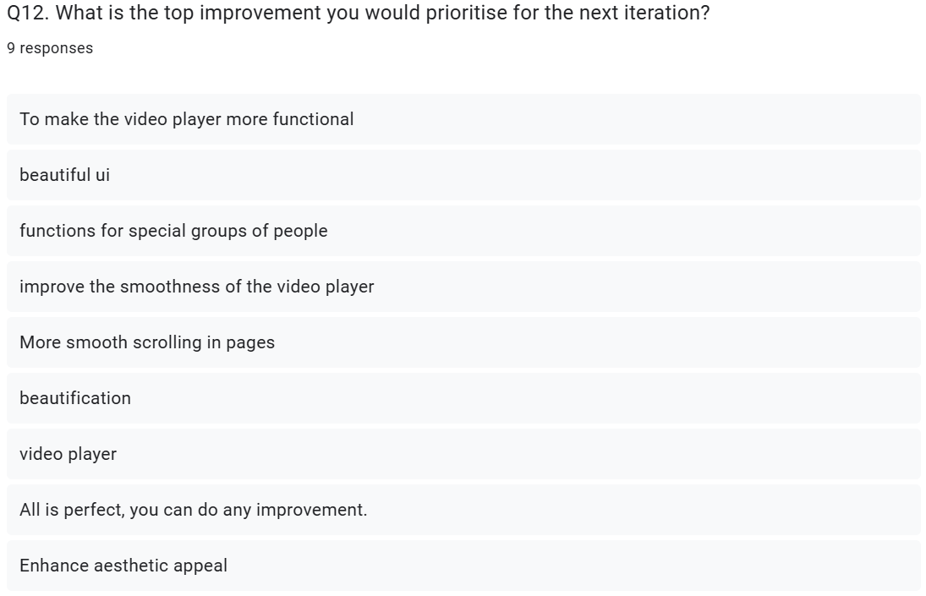
Figure5 Collected Opinions

The collected opinions imply that participants were quite impressive by our design style, but for video functions and scrolling in pages, we still needed to improve.

Based on the findings from field study, we identified and refined several key areas for product improvement to enhance usability and accessibility.

Regarding video-related functions, the following features are planned for implementation:

- Full-screen mode, to provide a more engaging and distraction-free viewing environment.

- Subtitle integration, catering to users in sound-sensitive environments and those with hearing impairments.

- An adjustable color contrast ratio, a critical feature that will make content more distinguishable for individuals with color blindness.

For the application as a whole, we intend to introduce two significant functional upgrades:

- Flexible font adjustment options, allowing users to personalize text size and style for optimal readability.

- Comprehensive internationalization settings, which will pave the way for multi-language support and regional formatting.

In addition, we will prioritize resolving the scrolling fluency issue to ensure smoother navigation and a more responsive interaction throughout the app.

Conclusion
In summary, the two-stage evaluation process play important roles in improvement directions making.

The initial evaluation corrected a fundamental misunderstanding of the product concept, while the subsequent field study provided direct, data-driven validation of our design direction and pinpointed specific user experience shortcomings.

